**RMK GROUP OF**

**INSTITUTIONS**

SOFTWARE REQUIREMENT SPECIFICATION

**TOPIC : HOSPITAL MANAGEMENT**

**SYSTEM**

**BY:**

**1.S.G.ANANDHI**

1. **J.JAISHREE**
2. **D.VINISHYA**

**4.AR.DEIVANAI**

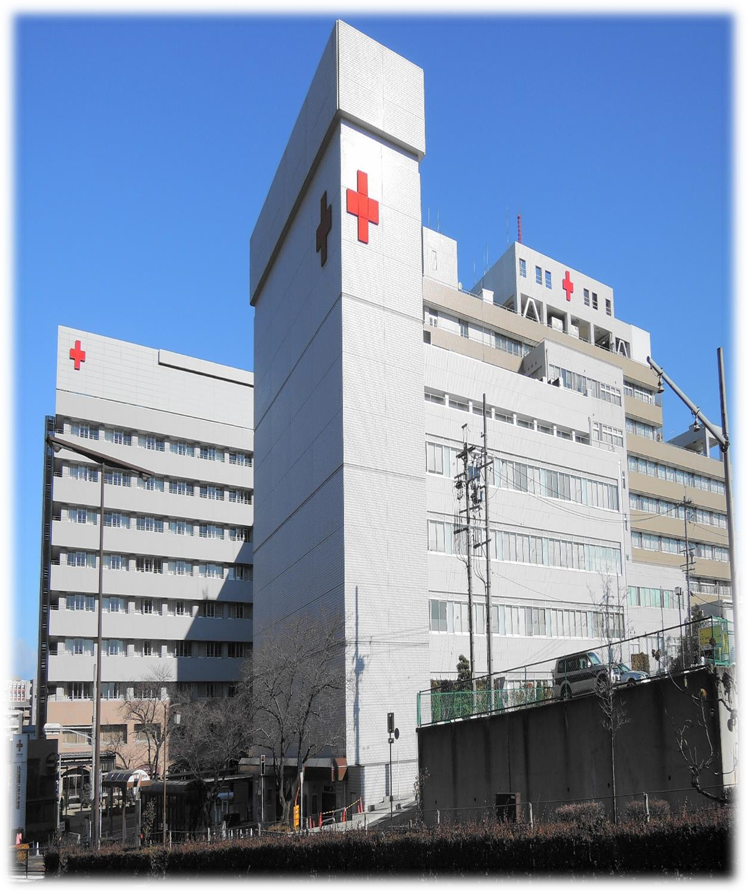

# 1.1 - Purpose

* The Software is for the automation of Hospital Management.
* It maintains two levels of users:-
  + Administrator Level
  + User Level
* The Software includes:-
  + Maintaining Patient details.
  + Providing Prescription, Precautions and Diet advice.

# 1.2 - Scope

• It can be used in any Hospital, Clinic, Dispensary or Pathology labs for maintaining patient details and their test results.

**1.3- External Interface Requirements**

## 1.3.1. User Interface:-

User interface is designed in a user friendly manner and the user, in another end he has to give the order, for that he will interface with keyboard and mouse. **1.3.2.** **Hardware Interface:-**

1. OS – windows XP
2. Hard disk – 80 GB
3. RAM – 1 GB
4. Keyboard – Standard QWERTY keyboard for interface
5. Mouse – Standard mouse with 2 buttons

**1.3.3. Software Interface:-** 1) Front end – Java language

1. OS – Net Beans IDE 6.9.1
2. Back end – SQL Server 2005

# 1.4 - Overview

* Project is related to Hospital Management System.
* The project maintains two levels of users:-
* Administrator Level-Doctor
* User Level-Data Entry Operator
* Main facilities available in this project are:-
* Maintaining records of patients.
* Maintaining patients diagnosis details, advised tests to be done.
* Providing test facilities to a doctor for diagnosis of patients.
* BP test
* Sugar test
* Maintaining patient’s prescription, medicine and diet advice details.
* Maintaining backup of data as per user requirments
* If user forgets his/her password then it can be retrieved by hint question.
* In this project collection of data is from different pathology labs.
* Results of tests, prescription, precautions and diet advice will be automatically updated in the database.
* Related test reports, patient details report, prescription.

User or Administrator can search a patient’s record by his/her name or their registration date

# 2.1- Goals of proposed system

1. **Planned approach towards working: - The working in the organization will** be well planned and organized. The data will be stored properly in data stores, which will help in retrieval of information as well as its storage.
2. **Accuracy: - The level of accuracy in the proposed system will be higher. All** operation would be done correctly and it ensures that whatever information is coming from the center is accurate.
3. **Reliability: - The reliability of the proposed system will be high due to the** above stated reasons. The reason for the increased reliability of the system is that now there would be proper storage of information.
4. **Easy to Operate: - The system should be easy to operate and should be such** that it can be developed within a short period of time and fit in the limited budget of the user.



# 2.2- Background

* A Hospital is a place where Patients come up for general diseases. Hospitals provide facilities like:-
* Consultation by Doctors on Diseases.
* Diagnosis for diseases.
* Providing treatment facility.
* Facility for admitting Patients (providing beds, nursing, medicines etc.)
* Immunization for Patients/Children.

This online management maintains:

* Patients details
* Prescription details
* Precautions
* Diet advice
* BP/sugar test

# 2.2- Background

The work is done as follows:-

* Information about Patients is done by just writing the Patients name, age and gender. Whenever the Patient comes up his information is stored freshly
* Diagnosis information to patients is generally recorded on the document, which contains Patient information. It is destroyed after some time period to decrease the paper load in the office
* Information about various diseases is not kept as any document. Doctors themselves do this job by remembering various medicines

## 2.3. User Characteristics:-

This software is developed such that total appearance of the product to make it more user friendly. The operator will be provided

with loginid and password. General users with

basic computer skills can use this software.

## 2.4. General Constraints:-

Any update regarding the patients information from the hospital are to be recorded to have updated and correct values.

### 2.5. Assumption and Dependencies:-

All the data entered will be correct and up to date .This software package is developed using java as front end which is supported by sun micro system, MS SQL server 2005 as the back end which is supported by Microsoft windows xp. 3. **SPECIFIC REQUIREMENTS** It describes all the details that the software developer need to know for designing and developing the system. This is typically the

largest and most important part of the document

### 2.6 Patient module:-

* Patient Id
* Name
* Age
* Sex
* Address
* Phone Number
* Weight

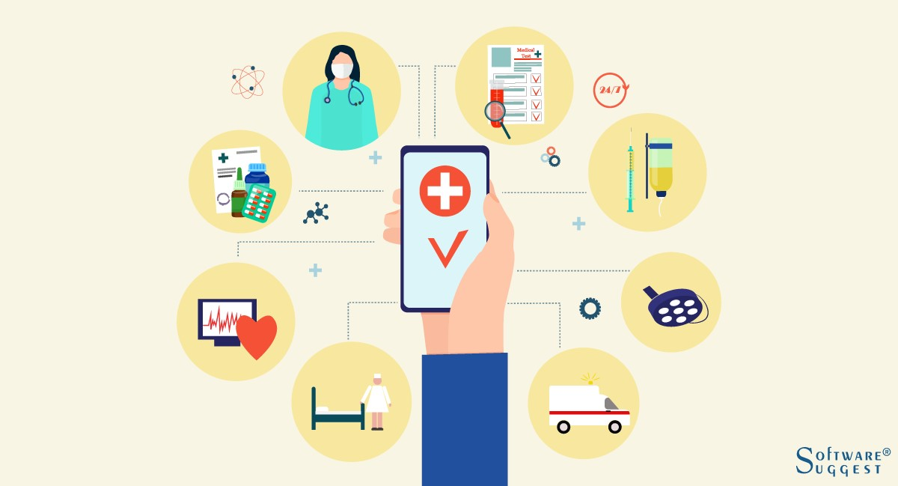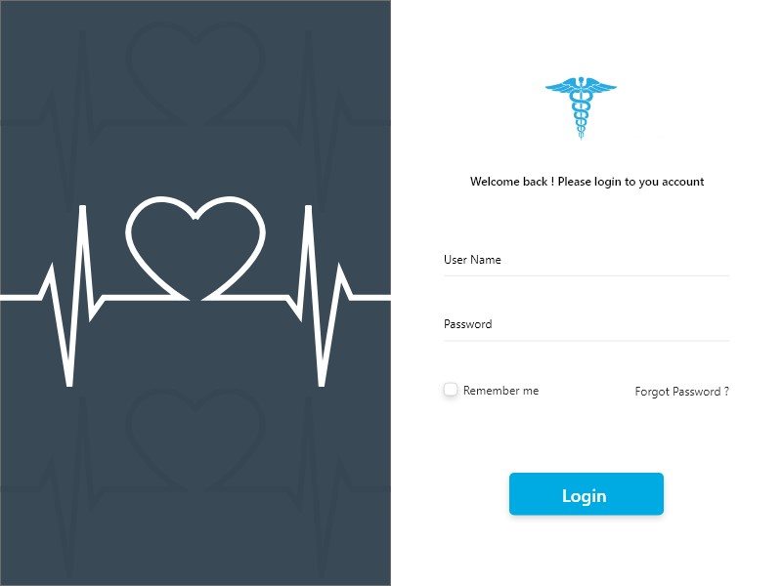

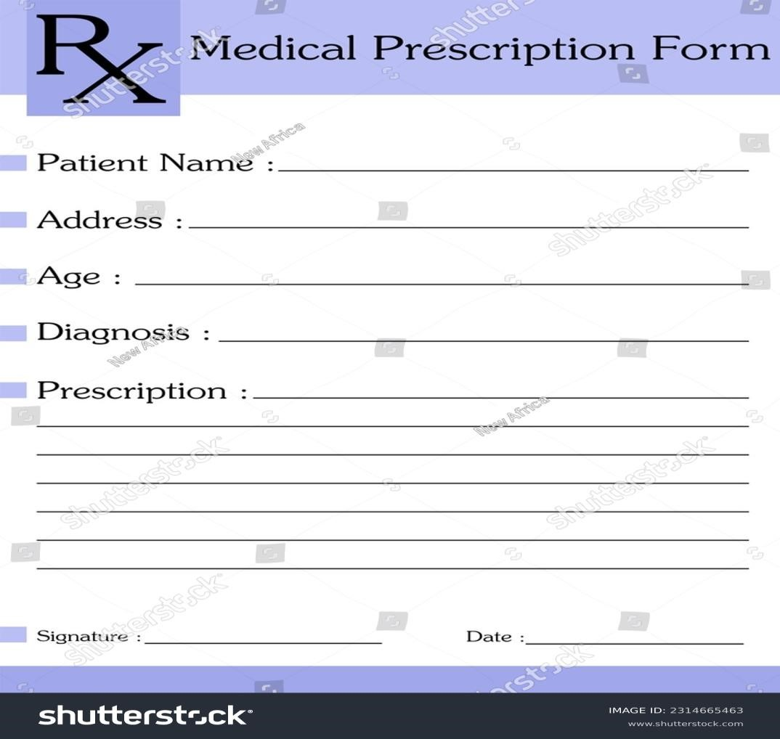

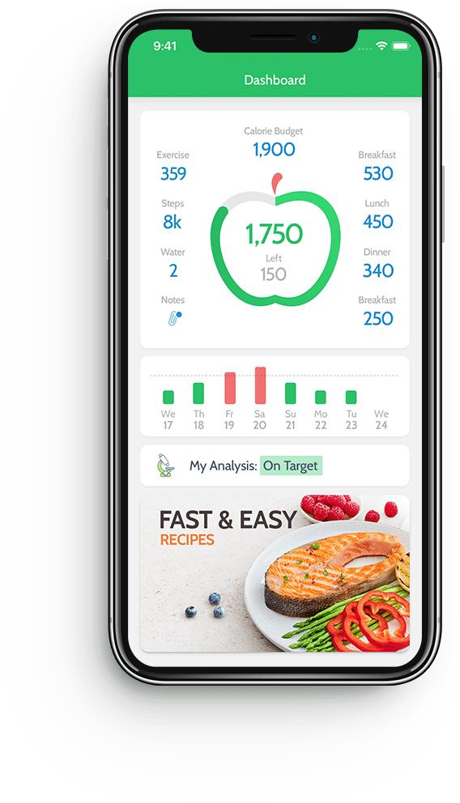

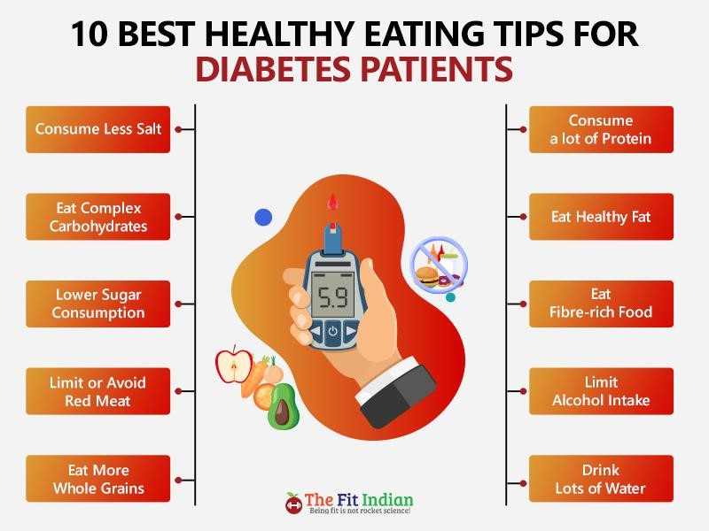

# THANK YOU